Error dated on 01.04.2021

1. This error is coming after change password.

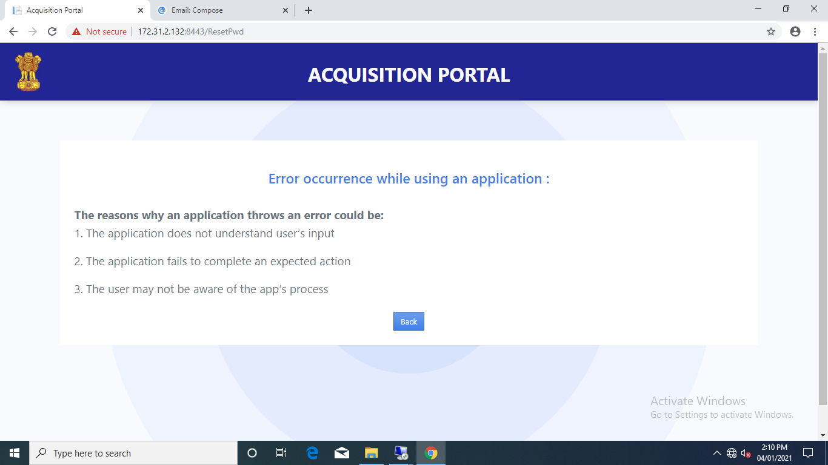

1. SOC/view SOC/ review/ cancel option is NOT working.
2. SOC/view SOC/ review/Comment/Back option redirect to login page.
3. SOC/view SOC/ review/Comment/Save comment option redirect to login page.
4. SOC/view SOC/ soc view / action / click sent email to all option after not show successfully popup.
5. Mom/ view meeting / Add meeting/ Save meeting to redirect to login page.
6. Mom/ view meeting/ print meeting with agenda to redirect to login page.
7. Mom/ view meeting /Prepare final meeting (spelling mistake Pepare final meeting)/ Back option redirect to login page.
8. Mom/ view meeting /send Email to participant’s option is not show email details.

Error dated on 05.04.2021

1. My profile/ Change password/Set a new password option is not working.

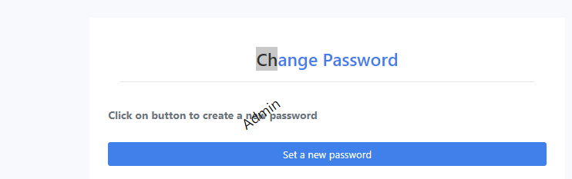

1. SOC / SOC upload /upload/ submit option is not working.

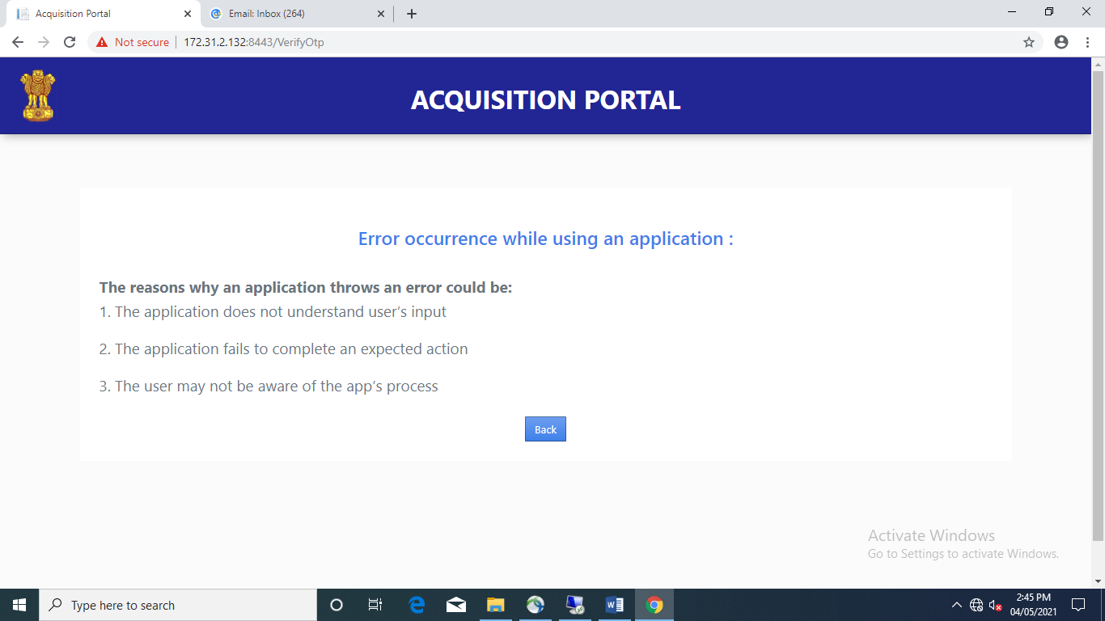

1. Account is not lock when User Name is wrong five times.
2. SOC/ SOC view/VIEW SOC/ COMMENT/SUBMIT OPTION IS not working.

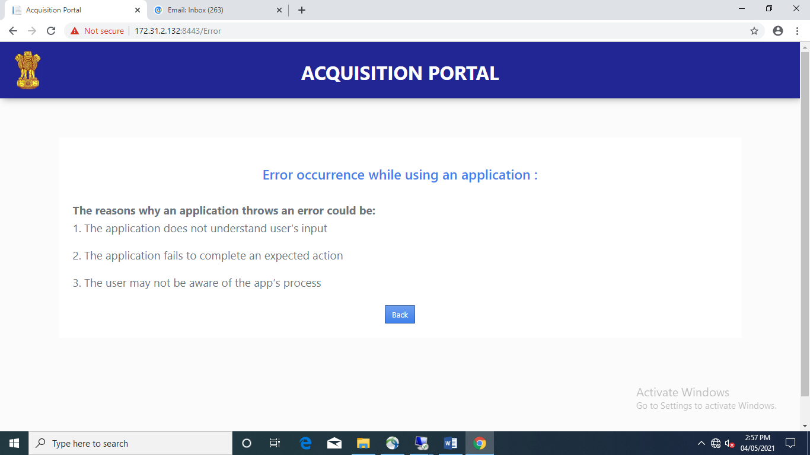

1. SOC/ SOC view/VIEW SOC/Action /click sent mail to all option is not showing successfully popup window.
2. Mom/ view meeting / Add meeting/ save meeting OPTION is not working and given error and click to blank submit redirects to static error page.
3. Mom/ view meeting / ACTION/ ADD Agenda /Back option to redirect to static error page.
4. Mom/ view meeting/ print meeting with agenda to redirect to static error page
5. Mom/ view meeting /Prepare final meeting (spelling mistake Pepare final meeting)/ Back option redirect to static error page
6. Mom/ view meeting /send Email to participant’s option is not show email details.